Auto Create Incident → Run Pipeline → Cleanup /tmp → Close Ticket
This setup will do:
Pipeline 1
Azure DevOps pipeline creates a ServiceNow Incident automatically.
Pipeline 2
When approved or triggered:
- Connect to Linux server
- Delete all files from /tmp
- Update ServiceNow incident
- Close the incident automatically
This is beginner-friendly and production-style.

Architecture Flow
Azure DevOps Pipeline
|
v
Create Incident in ServiceNow
|
v
Incident Number Generated
|
v
Run Cleanup Pipeline
|
v
rm -rf /tmp/*
|
v
Update Incident Notes
|
v
Close Incident

Prerequisites
Azure DevOps
Need:
- Azure DevOps Organization
- Project
- Repo
- Pipelines enabled
ServiceNow
Need:
- Developer Instance
- Admin Access
Create free instance:
ServiceNow Developer Portal
Linux Server
Ubuntu VM or any Linux VM.
- Agent configured and running

STEP 1 — Create ServiceNow Developer Instance
Open:
ServiceNow Developer Instance Signup
Create instance.
Example:
Instance URL:
https://dev12345.service-now.com

STEP 2 — Create ServiceNow User for API
In ServiceNow:
Users → New
Create:
Username: azuredevops
Password: StrongPassword123
Give roles:
itil
rest_service
admin
NOTE: Reset the passwrod and don’t save.
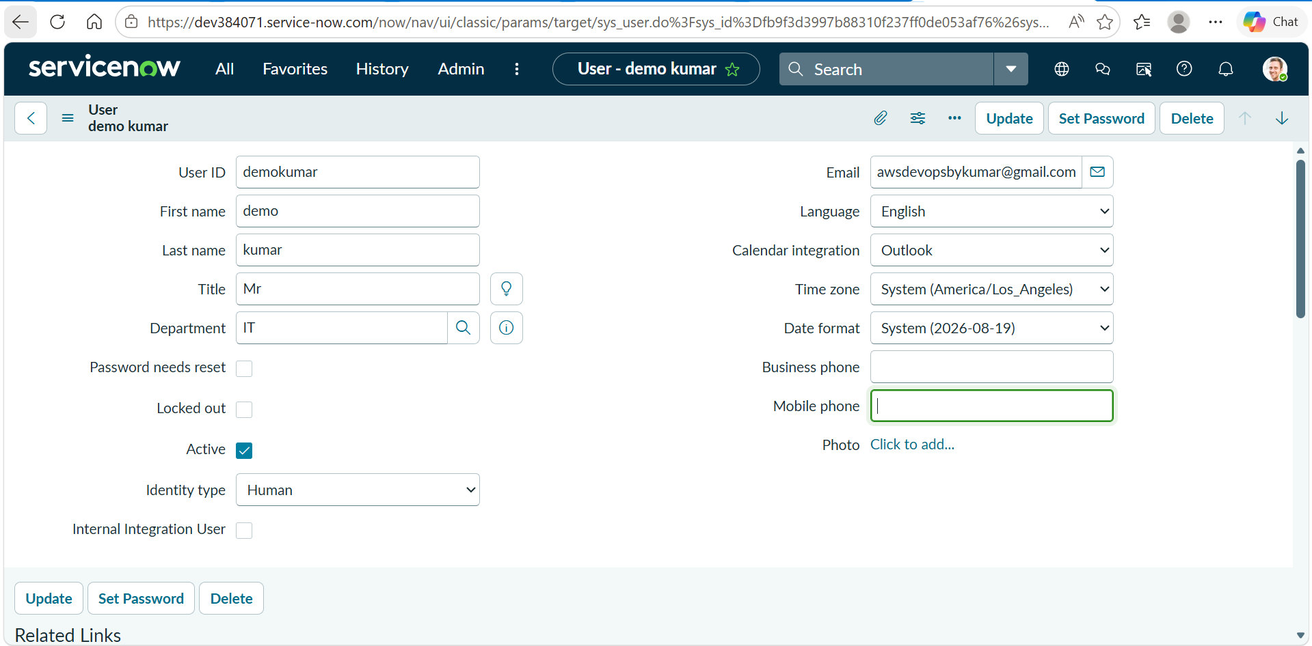

STEP 3 — Test ServiceNow API
Open Postman or Linux terminal.
curl -X GET \
'https://dev12345.service-now.com/api/now/table/incident?sysparm_limit=1' \
--user 'azuredevops:StrongPassword123' \
--header 'Accept: application/json'
If successful:
{
"result": [...]
}

STEP 4 — Create Azure DevOps Project
Open:
Azure DevOps
Create:
Project Name: servicenow-demo

STEP 5 — Create Repository
Inside Azure DevOps:
Repos → Initialize
Clone repo locally:
git clone https://dev.azure.com/YOURORG/servicenow-demo/_git/servicenow-demo

STEP 6 — Create Azure DevOps Variable Group
Go:
Pipelines → Library → Variable Group
Create:
Group Name: servicenow-vars
Add variables:
Variable | Value
SN_INSTANCE | dev12345.service-now.com
SN_USER | Azuredevops
SN_PASS | Password

STEP 7 — Create Pipeline 1 (Incident Creation)
Create file:
azure-pipelines-create-incident.yml
Code:
trigger: none
pool:
name: demo
variables:
- group: servicenow-vars
steps:
- task: Bash@3
displayName: Create ServiceNow Incident
inputs:
targetType: 'inline'
script: |
echo "Creating Incident..."
RESPONSE=$(curl -s -X POST "https://$(SN_INSTANCE)/api/now/table/incident" \
--user "$(SN_USER):$(SN_PASS)" \
--header "Content-Type: application/json" \
--data '{
"short_description":"Temp folder cleanup required",
"description":"Delete all files from /tmp folder",
"urgency":"2",
"impact":"2"
}')
echo $RESPONSE
INCIDENT=$(echo $RESPONSE | jq -r '.result.number')
echo "Incident Created: $INCIDENT"
echo "##vso[task.setvariable variable=INCIDENT_NUMBER]$INCIDENT"

STEP 8 — Run Pipeline 1
Go:
Pipelines → New Pipeline
Select YAML file:
azure-pipelines-create-incident.yml
Run pipeline.
Expected:
Incident Created: INC0010001

STEP 9 — Verify Incident in ServiceNow
Go:
Incident → All
You should see:
Temp folder cleanup required

STEP 10 — Create Pipeline 2 (Cleanup + Close Incident)
Create file:
azure-pipelines-cleanup.yml
Code:
trigger: none
pool:
name: demo
variables:
- group: servicenow-vars
steps:
- task: Bash@3
displayName: Delete /tmp Files
inputs:
targetType: inline
script: |
echo "Cleaning /tmp folder..."
sudo rm -rf /tmp/*
echo "Cleanup completed"
- task: Bash@3
displayName: Close ServiceNow Incident
inputs:
targetType: inline
script: |
INCIDENT="INC0010001"
SYS_ID=$(curl -s \
--user "$(SN_USER):$(SN_PASS)" \
"https://$(SN_INSTANCE)/api/now/table/incident?sysparm_query=number=$INCIDENT" \
| jq -r '.result[0].sys_id')
echo "SYS_ID=$SYS_ID"
curl -X PATCH \
"https://$(SN_INSTANCE)/api/now/table/incident/$SYS_ID" \
--user "$(SN_USER):$(SN_PASS)" \
--header "Content-Type: application/json" \
--data '{
"state":"6",
"close_notes":"Cleanup completed successfully",
"close_code":"Solved (Permanently)"
}'
echo "Incident Closed"

STEP 11 — Run Cleanup Pipeline
Run:
azure-pipelines-cleanup.yml
Expected:
Cleaning /tmp folder...
Cleanup completed
Incident Closed

STEP 12 — Verify in ServiceNow
Incident should now show:
State = Resolved
Close Notes = Cleanup completed successfully

Folder Structure
servicenow-demo/
│
├── azure-pipelines-create-incident.yml
├── azure-pipelines-cleanup.yml

